Decision Tree Balance โดยใช้อัลกอริทึมCTGAN (Conditional Tabular GAN) ชื่อยา + Specimen + เพศ + อายุ + หอผู้ป่วย
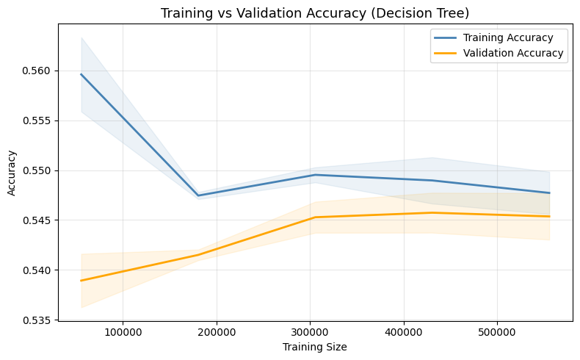
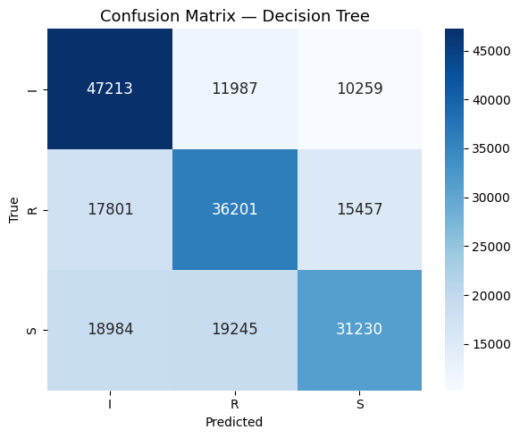
Classification Report:
Accuracy: 55.02%
 | precision | recall | f1-score | support
I | 0.56 | 0.68 | 0.62 | 69459
R | 0.54 | 0.52 | 69459 | 69459
S | 0.55 | 0.45 | 0.49 | 69459
accuracy |  |  | 0.55 | 208377
macro avg | 0.55 | 0.55 | 0.55 | 208377
weighted avg | 0.55 | 0.55 | 0.55 | 208377
Random Forest
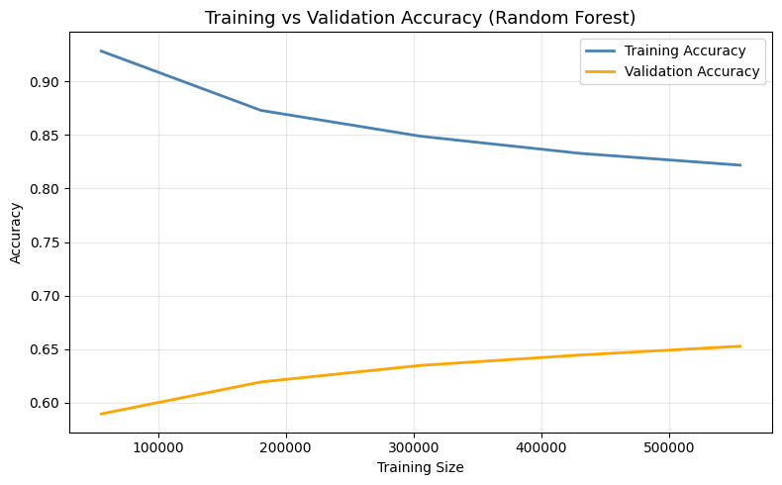
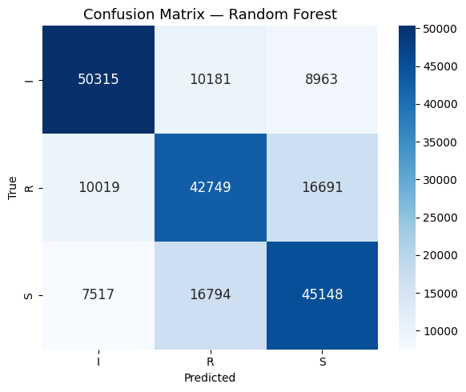
Classification Report:
Accuracy: 66.33%
 | precision | recall | f1-score | support
I | 0.74 | 0.72 | 0.73 | 69459
R | 0.61 | 0.62 | 0.61 | 69459
S | 0.64 | 0.65 | 0.64 | 69459
accuracy |  |  | 0.66 | 208377
macro avg | 0.66 | 0.66 | 0.66 | 208377
weighted avg | 0.66 | 0.66 | 0.66 | 208377

XGBoost
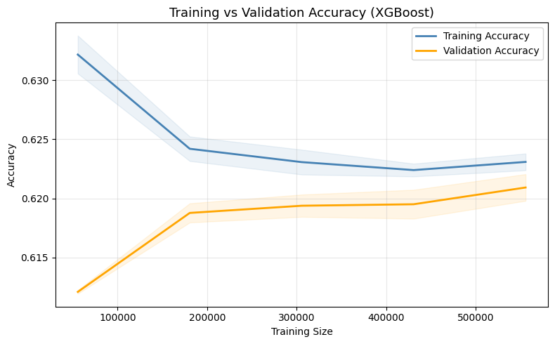
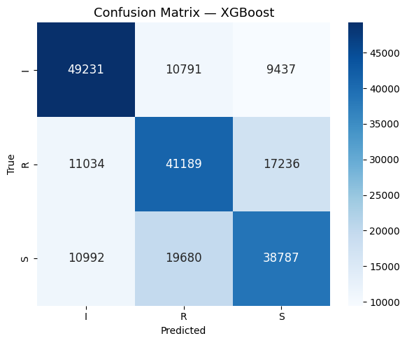
Classification Report:
Accuracy: 62.01%
 | precision | recall | f1-score | support
I | 0.69 | 0.71 | 0.70 | 69459
R | 0.57 | 0.59 | 0.58 | 69459
S | 0.59 | 0.56 | 0.57 | 69459
accuracy |  |  | 0.62 | 208377
macro avg | 0.62 | 0.62 | 0.62 | 208377
weighted avg | 0.62 | 0.62 | 0.62 | 208377

CatBoost
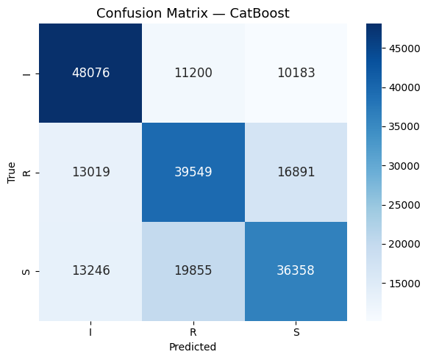
Classification Report:
Accuracy: 59.50%
 | precision | recall | f1-score | support
I | 0.65 | 0.69 | 0.67 | 69459
R | 0.56 | 0.57 | 0.56 | 69459
S | 0.57 | 0.52 | 0.55 | 69459
accuracy |  |  | 0.59 | 208377
macro avg | 0.59 | 0.59 | 0.59 | 208377
weighted avg | 0.59 | 0.59 | 0.59 | 208377

STEP 6.7 — Model Comparison
Model Test Acc Precision Recall F1
Decision Tree 0.5502 0.5491 0.5502 0.5461
Random Forest 0.6633 0.6641 0.6633 0.6636 ✅
XGBoost 0.6201 0.6194 0.6201 0.6195
CatBoost 0.5950 0.5933 0.5950 0.5935 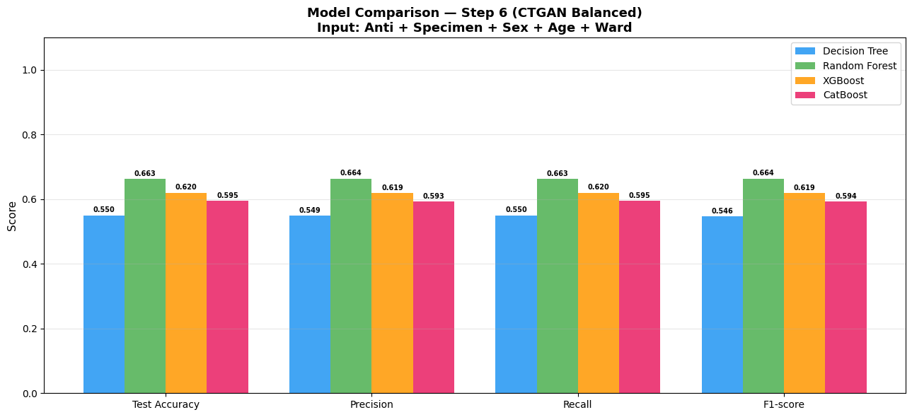
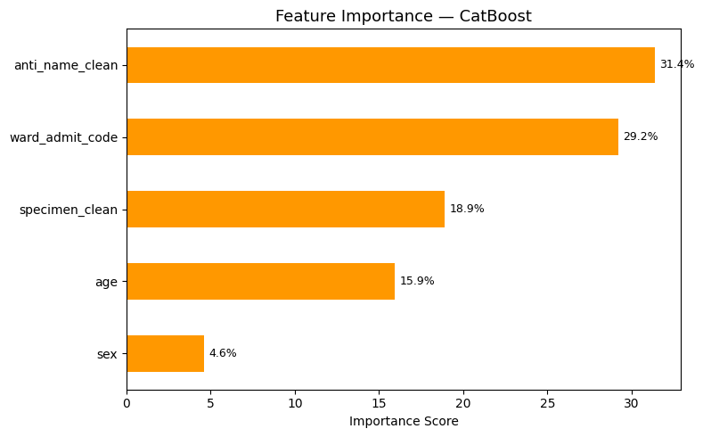
Best Model : Random Forest
Test Accuracy : 66.33%
Macro F1 : 0.6636
============================================================

